Edge Offloading Decision System Using Machine Learning

Introduction
The project Smart ML DecisionMaker is designed to assist in intelligent decision-making for task offloading in edge computing environments. The system determines whether a computational task should execute locally on a device or be offloaded to the cloud.
The decision framework combines machine learning (ML) models with a rule-based cost formulation, designed to simulate real-world noisy data and network conditions.

Problem Statement
In modern edge-cloud environments, deciding whether to offload a task to the cloud or execute it locally is complex. Factors like CPU usage, battery level, network latency, bandwidth availability, and data size all influence this decision.
Traditional rule-based approaches often fail to generalize in noisy, dynamic environments.
The problem is to build a system that can accurately predict the optimal offloading decision, handle noisy, incomplete data, and combine rule-based logic and ML for robust decision-making.

Problem Formulation

Objectives
- Develop a hybrid offloading decision system using ML models and rule-based cost functions.
- Generate synthetic noisy datasets to simulate real-world variability.
- Evaluate and compare ML accuracy vs rule-based performance.
- Provide a GUI for inputting task parameters and displaying decisions from both approaches.

Constraints
- Synthetic dataset may not capture every real-world scenario.
- Cost formulas use assumed weights, not measured energy.
- Simplified rule-based model may not cover complex offloading requirements.

Methodology

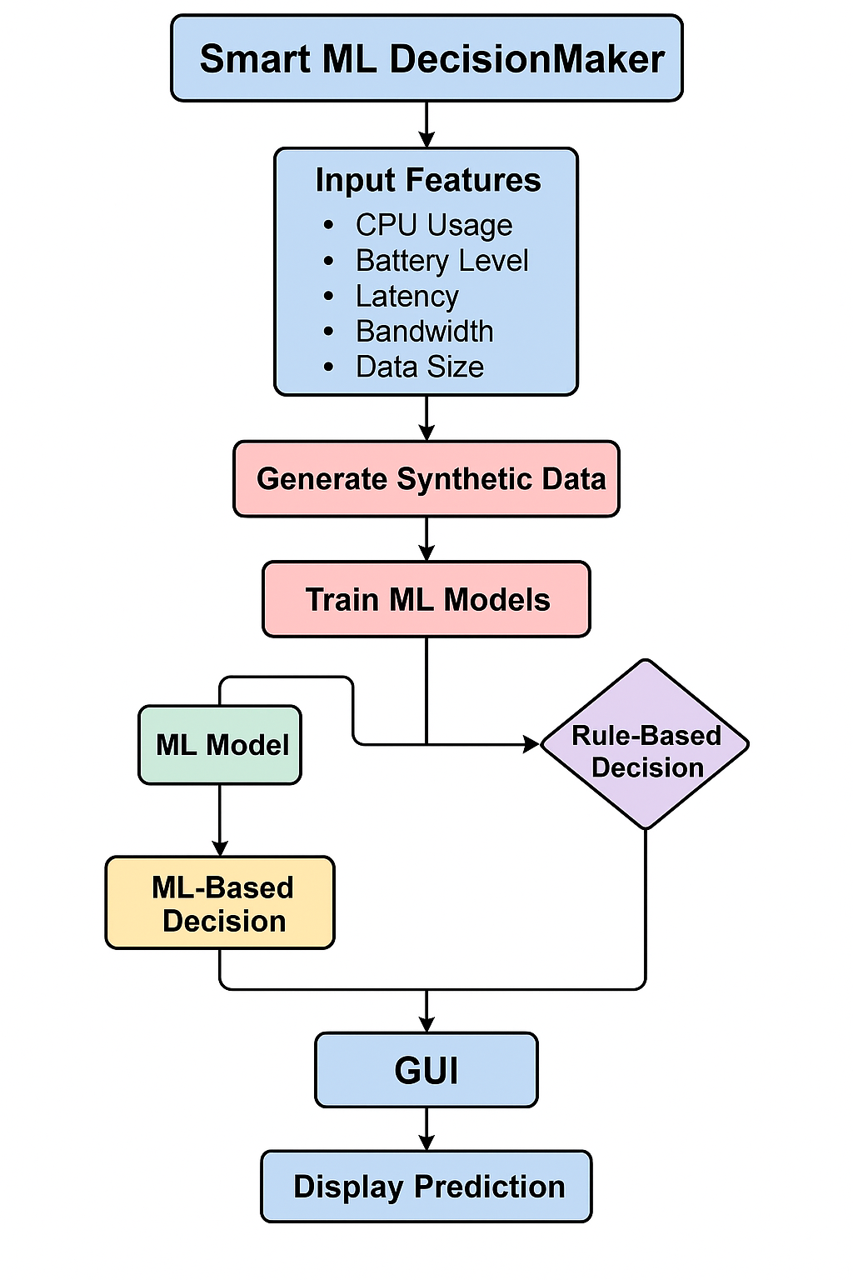

Equations
Decision = 0 if Cost_Local < Cost_Cloud else 1
Cost_Local = α * Energy_Local + β * Time_Local
Cost_Cloud = α * Energy_Cloud + β * Time_Cloud
Energy_Local = (100 - Battery) * 0.2 + CPU * 0.8
Energy_Cloud = (100 - Battery) * 0.4
Time_Local = Latency
Time_Cloud = Latency + (Data_Size / max(Bandwidth,1)) * 10 + 5

Implementation / Simulation
- Synthetic noisy dataset of 10,000 samples with outliers, missing values, realistic variation.
- ML models: Decision Tree, Random Forest, Neural Network (MLP), SVM, Logistic Regression, KNN.
- Rule-based system using cost function derived from formulation.
- Data Split: ~80% for Training | ~20% for Testing
- GUI developed for both ML and rule-based inputs.
- ML models achieved ~85-95% accuracy on test data.
- Rule-based system accuracy initially ~51%, improved after tuning.
- Final rule-based decision split: ~52% offload, 48% local.
- ML models outperform rule-based logic in matching ground truth.

Performance of Decision Tree:
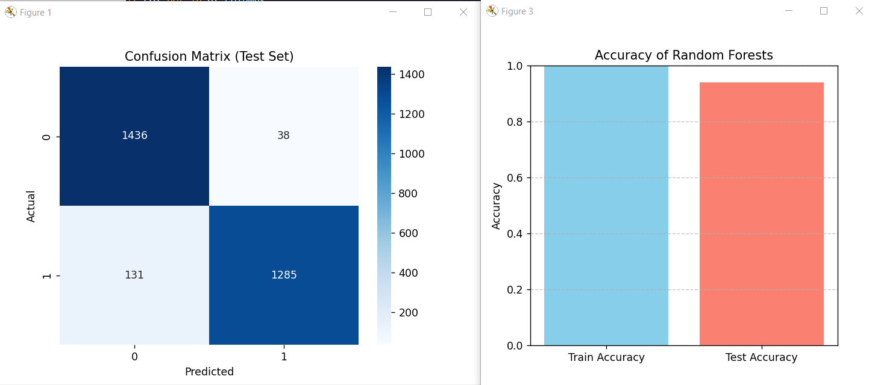
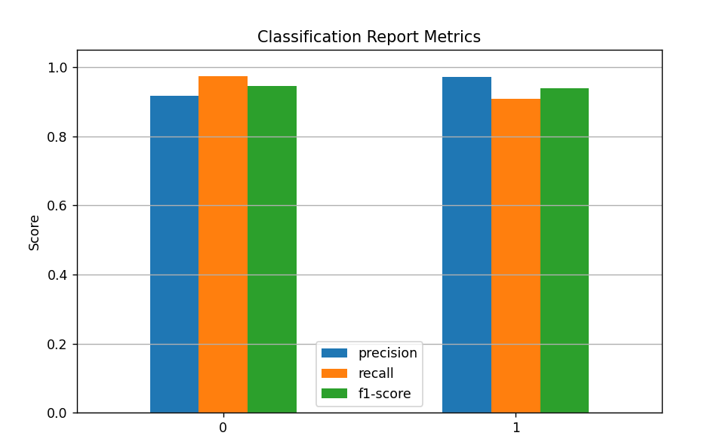

Results:
